**Assumptions made**

* Only 1 theatre and 1 cinema
* Movie table stores movie as well as the screening time. Each movie row can have the same name and other details except its showing start time.
* Each movie row has its own sets of seats.(1 movie row is tied to 1 seat row)
* Each seat is tagged to each reservation, which the reservation table is used to track the status of the seats as well as the customer it is assigned to upon completetion.

**App Flow**

1. User will first arrive at the home page where he can choose the movies to book seats for.

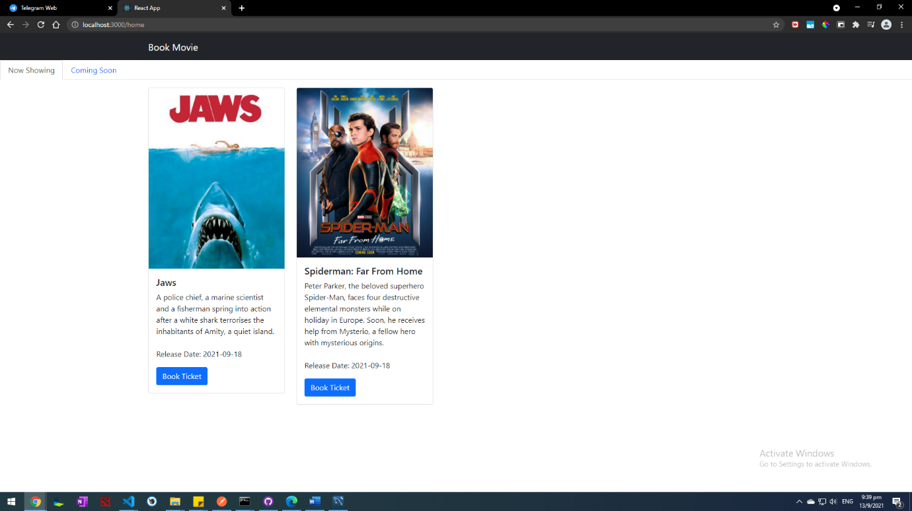

1. Upon choosing the movie, he will be brought to the seats selection page, which the seats will load according to the seat timing he have selected.

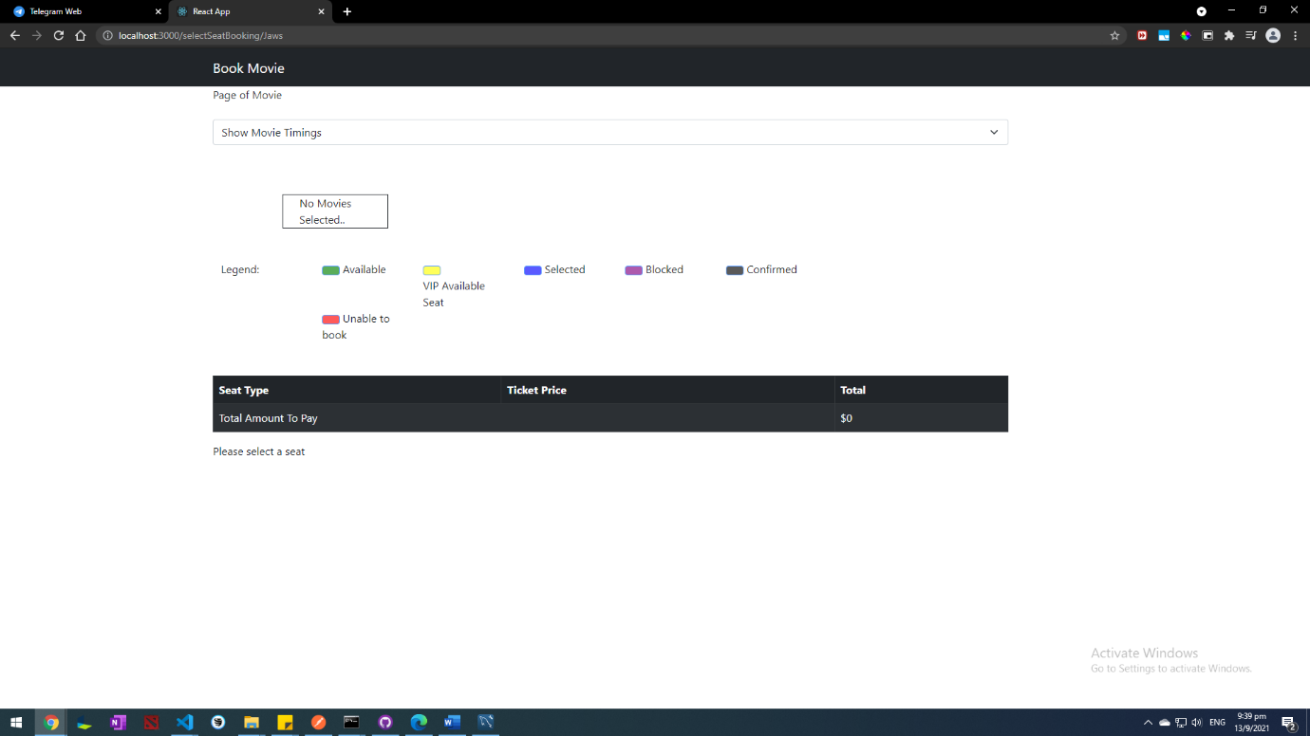

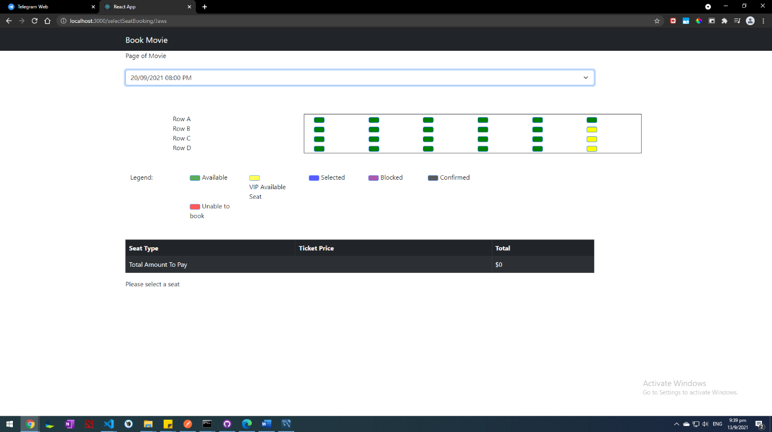

1. The seats selected will be reflected as blue and the total amount to pay is shown in the table below.

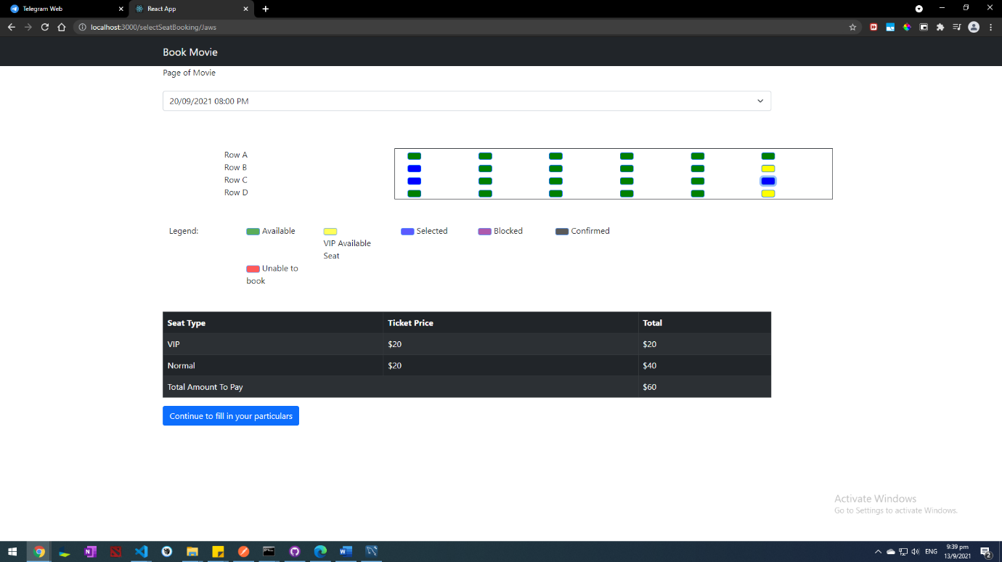

1. Upon successfully choosing the seats, user would then be directed to the confirm booking page. The seats will be reflected to other users as blocked and is not available for selection. There is a 10 minute limit for user to fill in his information and confirm the booking, as shown via the timer. When the timer reaches zero, the user will be redirected out of the page and the seats will be updated back to be available for booking.

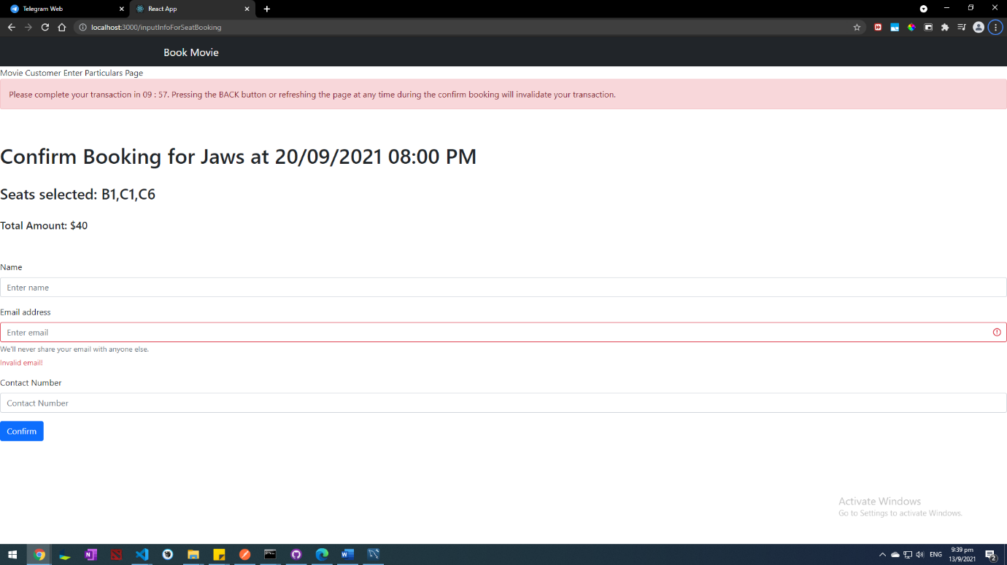

1. The User would then be shown with this page after successful confirmation.

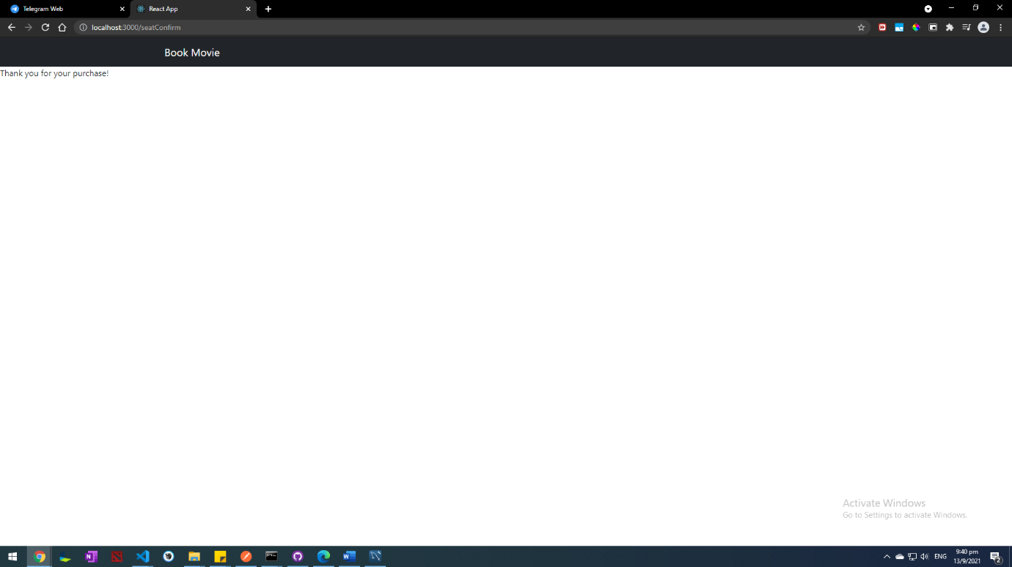

1. An email would also be sent to the user with the booking details.

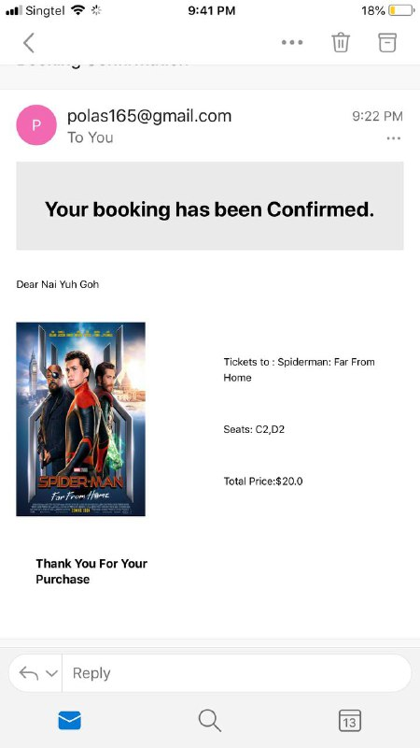

Upon successfully choosing the seats, user would then be directed to the confirm booking page